December 2018
Year 3 2019 Stationery requirements

Dear Parents,
. Listed below are the items your child will need for the start of Year 3. Exercise books are provided by the school.
Please purchase and label the following:
- 2 x pencil cases-
IMPORTANT: The small pencil case is for everyday use on your child’s desk. Textas, coloured pencils, ruler, scissors and all other items in a bigger one in their tub. This allows for maximum working space on their desk.
- 1 x plastic wallet folder
- Coloured pen (for editing)
- 10 x HB pencils
- Coloured textas
- Coloured pencils
- Sharpener- with a shaving catcher (not electric)
- Eraser
- Clear 30cm ruler not bendable
- Scissors
- 3 x highlighters in different colours
- 4 x glue sticks each term– (Bostik Blu Stik only brand new to WHS)
- Art shirt/smock
- Calculator with large buttons
- 1 box of tissues (for class use)
- Whiteboard markers (for use with mini whiteboards)
- Headphones (for use in ICT lab)
- A4 Sketch Pad
- Coles brand wipes (no chemicals)
- Air modelling clay
Homework items:
Please make these items available in your child’s homework area:
- One USB for homework projects
- Primary Dictionary for homework

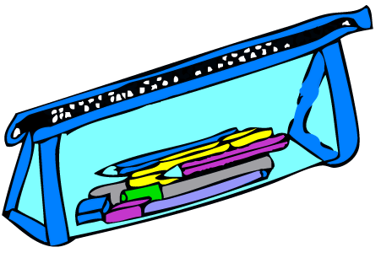

Please Note:
- ALL items need to be labelled including school clothes, lunch boxes, drink bottles etc.
We are looking forward to working with you in 2019. Enjoy your holidays!

Mrs Chang and Mrs Baldwin

