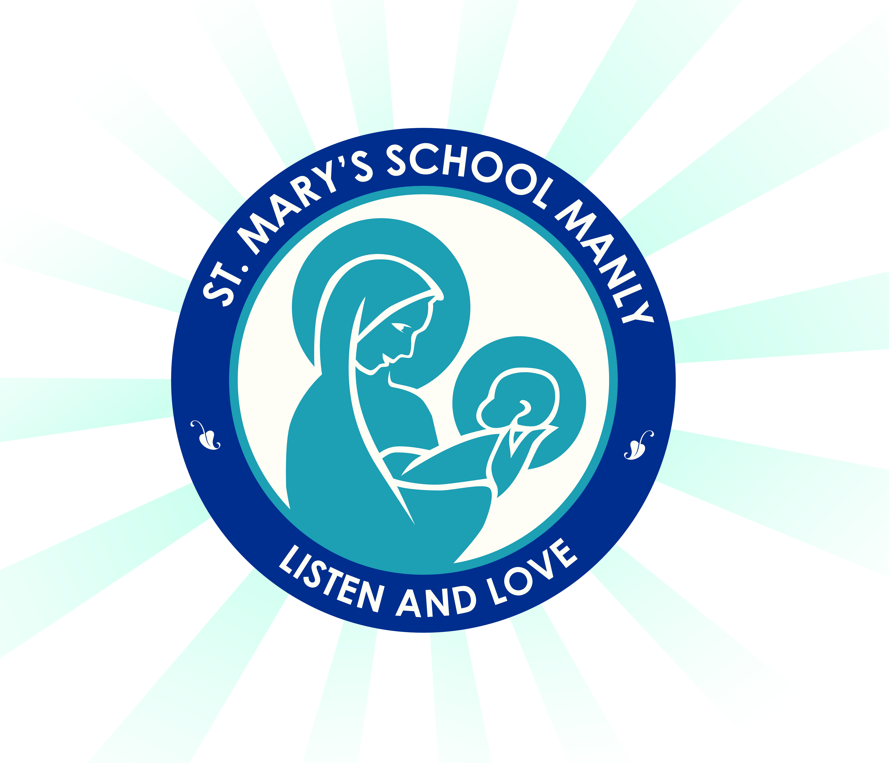
St Mary’s Catholic Primary School- Year 5 2019 Stationery List

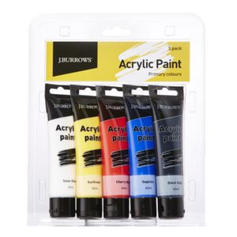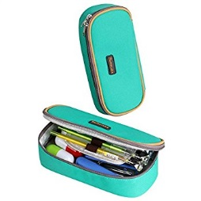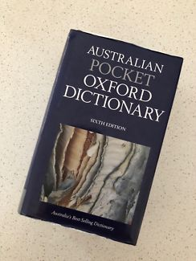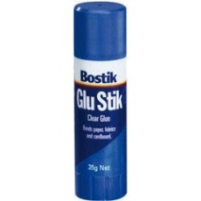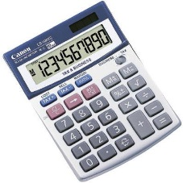
Dear Parents/Carers,
As the year comes to an end, it is time to begin preparing for 2019. Listed below are the stationery and other items that your child will need to start the year. Students will be provided with the exercise books that they require for each subject area and a Student Diary for 2019. Please have clear contact ready for covering when books have been labelled correctly at school. Please note that white out/liquid paper is not to be brought to school. (WHS requirement)

Items needed to be purchased by families:
- Dictionary preferably the ‘Australian Pocket Oxford Dictionary’ It is also useful to have a good dictionary, thesaurus, and maths dictionary at home.
- 2 Boxes of tissues (for class use)
- Art Shirts or apron (they must be worn during art activities)
- Washable student acrylic tube paint set-pack of 6 colours (red, yellow, blue, black and white). Available at Officeworks or Big W for around $15. Please don’t select a set that is more expensive.
- Calculator
- A USB at least 2GB
- 3 A4 display folders- Homework, Peer Support and English and Maths Worksheets

Please provide two well stocked pencil cases. Please have one small pencil case for everyday pens only and another small pencil case will stay in the student’s tubs for other writing/drawing utensils.
Including:
- 4 blue, 4 other colour pens
- 4 2B or HB lead pencils
- Colour pencils
- Sharpener and eraser
- Ruler – clear, 30cm
- Scissors
- Coloured textas
- Highlighters
- Post it notes- 2 packets
- 4 x Glue sticks – (Bostik blu stik- medium/large only because of WHS requirements)
- Geometry Set - protractor and compass are needed
- Headphones- don’t need to be expensive
- 2 permanent black markers- similar to a “Sharpie” size
- Set of 4 Whiteboard markers
- Clear contact for book covering

Please ensure that all items are clearly labelled. This also includes school clothing, hats, lunch boxes, drink bottles etc.
Have a restful and happy holiday. We’re looking forward to having a fantastic 2018.

Mrs Williams and Mrs Marshall

