Year 1 2020 Wish List
(Kindergarten 2019)
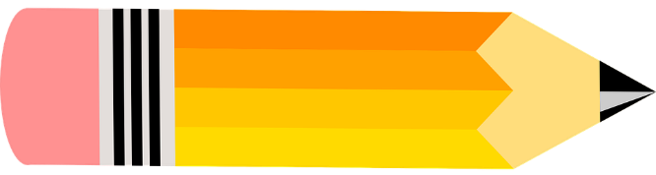

Dear Parents,

Please supply your child with the following items for the beginning of the school year 2020.

The following items are to be shared with the class. Labelling of these items is not required.
- 1 pack of wind up crayons (12pk)
- 4 x BOSTIK BLU LARGE Glue Sticks
- 1 pack of multi-coloured whiteboard markers.
- 1 tissue box

The following items are to be clearly labelled with your child’s name.
- 1 art shirt
- 1 large button calculator
- 1 school library bag
- 3 x clear plastic document wallets
- 1 pack of coloured textas (12pk) – individually labelled
- 1 30cm clear plastic ruler
- 1 pencil case (just large enough for the textas)
- 1 set of head phones (not ear buds please)
- 1 medium tub of Play-Doh.

Please Note:
- ALL items need to be labelled including school clothes, lunch boxes, drink bottles etc.

It is optional that the children in Year 1 will use clear contact to protect their workbooks. It is easier to recycle the books if left uncovered.

Thank you for your continued support and we look forward to an exciting 2020! We wish you all the very best for a happy and safe Christmas

Kind regards Miss Paul and Mrs Conn
Year 1 Teachers

