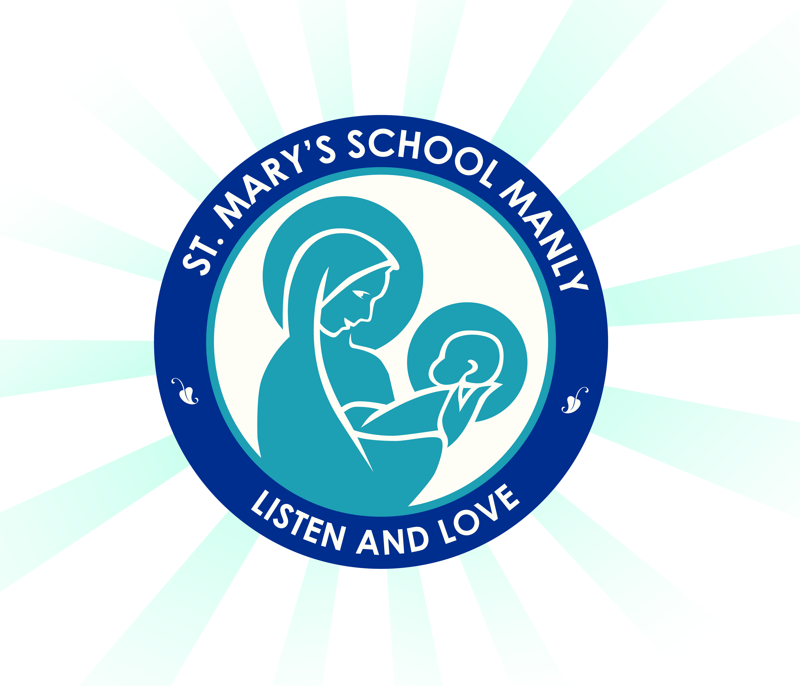

December 2019

Year 2 2020 Stationery Requirements

Dear Parent/s,
As the year comes to an end it is time to begin preparing for 2020. Listed below are the items that your child in Year 2 will need to start the year so that they are prepared. The books your child will use are provided by the school. Please make sure your child has this on day one of Term 1 and all items are labelled.

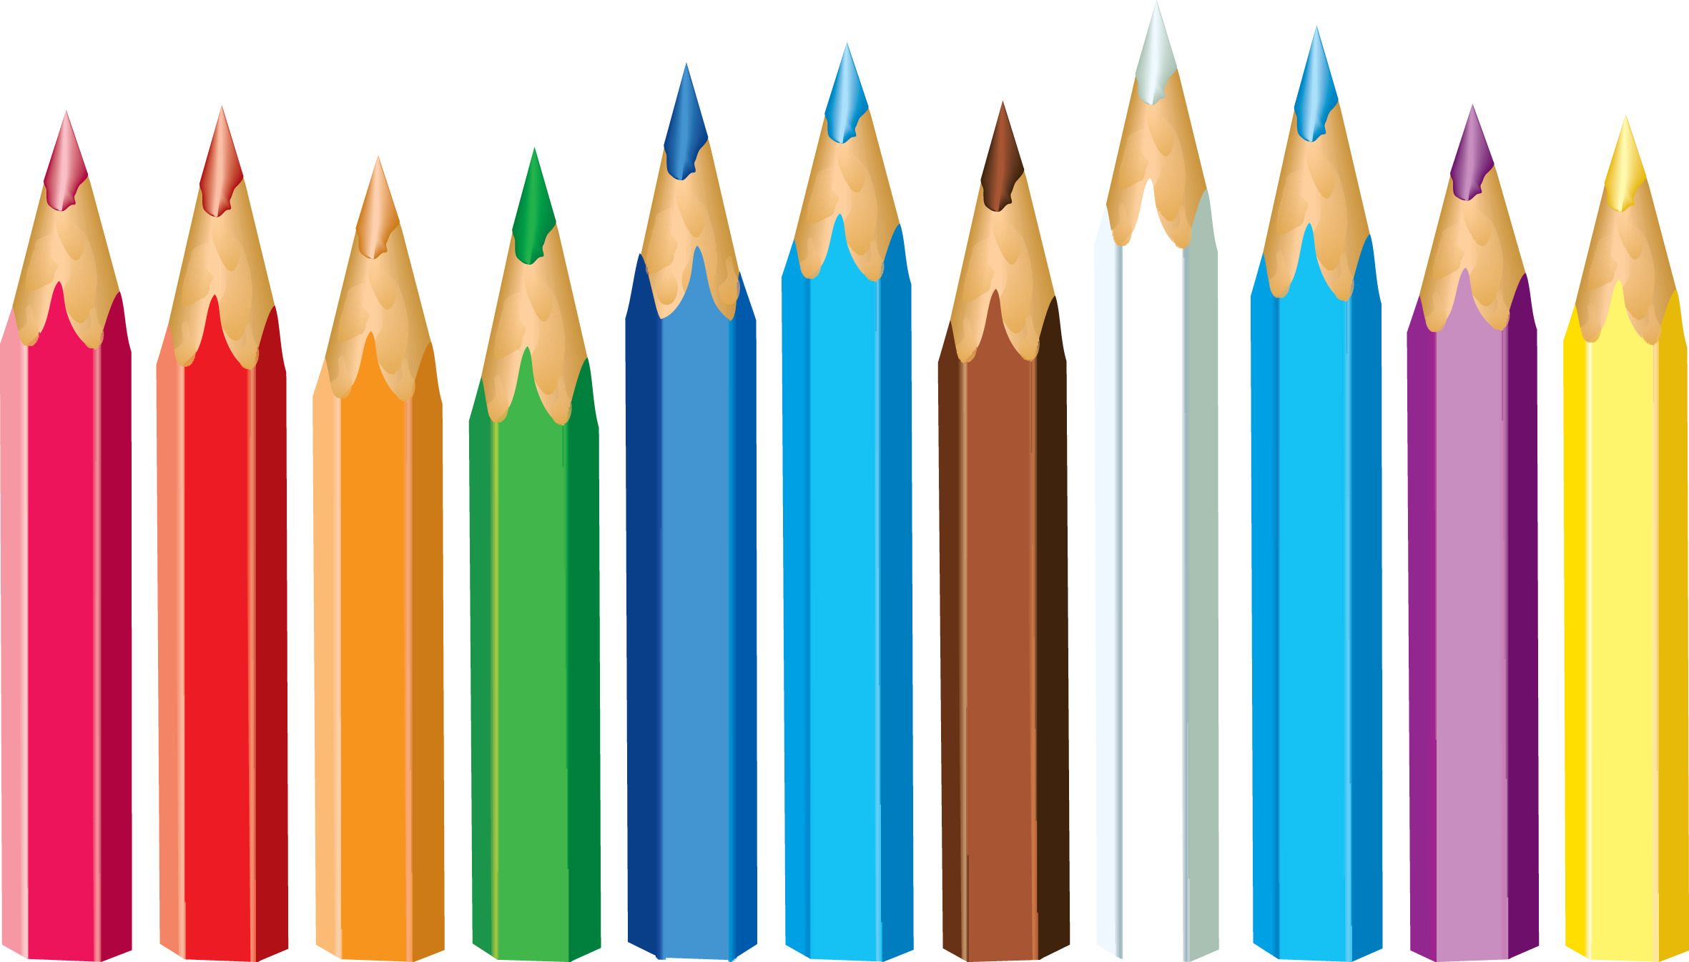
- 2 x plastic wallet folder (Notes and Home Readers)
- 4 x plastic sleeved display folders
- 12 HB pencils
- Coloured textas
- Coloured pencils or crayons
- Sharpener with a shaving catcher (not electric)
- Eraser
- 1 x pack Whiteboard markers
- Clear 30cm ruler (not bendable)
- Medium Scissors
- 3 x highlighters in different colours
- 1 packet of gel pens (for editing)
- 6 x large glue sticks (Bostik Blu Stik only due to WHS)
- 2 x pencil cases- please provide 2 well stocked pencil cases. Please have one small pencil case for everyday lead pencils only. Colour textas and pencils can be kept in a bigger one.
- Art shirt/smock/over sized t-shirt (they must be worn during art activities)
- Non-scientific calculator
- Headphones
- One USB for homework and school projects
- 2 x boxes of tissues
- 1 x A4 art sketch book

NB. White out/liquid paper is not to be brought to school (WHS requirement).

ALL items need to be labelled including school clothes, lunch boxes, drink bottles etc. Labelling reduces stress and conflict. It saves a lot of time in returning lost property. Enjoy your holidays. We are looking forward to working with you in 2020.

Mrs Whealing, Mrs Jenkins and Mrs Hankin
Year 2 Classroom Teachers

