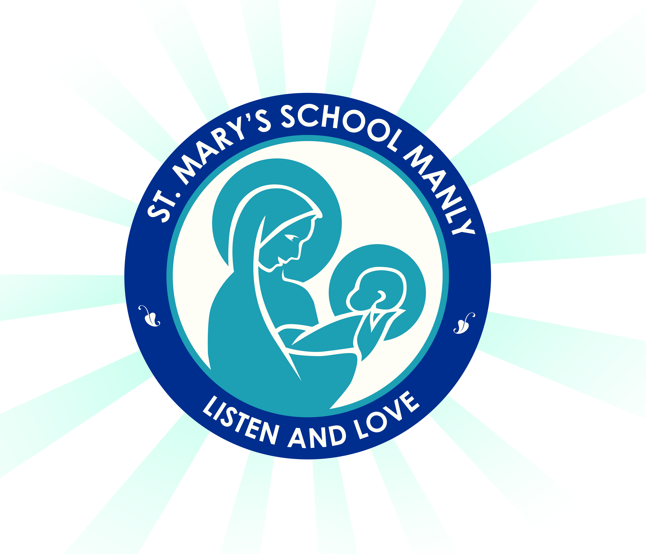

Year 2 2021 Stationery List

Dear Parent/s,

As the year comes to an end it is time to begin preparing for 2021. Listed below are the items that your child in Year 2 will need to start the year so that they are prepared. The books your child will use are provided by the school. Please make sure your child has all items on day one of Term 1 and all items are labelled.

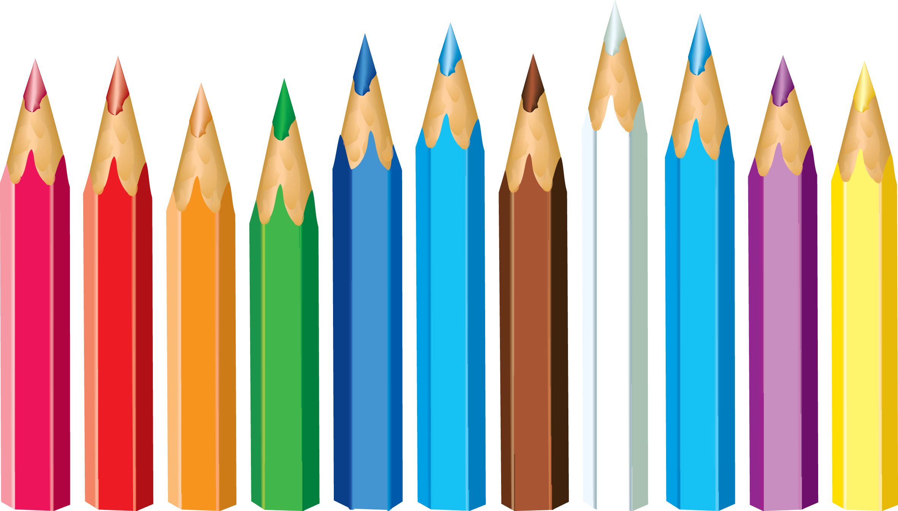
- 1 x plastic wallet folder
- 4 x plastic sleeved display folders
- 14 HB pencils
- Coloured textas
- Coloured pencils or crayons
- Sharpener with a shaving catcher (not electric)
- Eraser
- 1 x pack Whiteboard markers
- 1 x black permanent marker (similar to Sharpie)
- Clear 30cm ruler (not bendable)
- Medium Scissors
- 2 x highlighters in different colours
- 1 packet of gel pens
- 3 x large glue sticks (Bostik Blu Stik only due to WHS)
- 2 x pencil cases (Please have one small pencil case for everyday lead pencils only. Coloured textas and pencils can be kept in a bigger one.)
- Art shirt/smock/over sized t-shirt
- Non-scientific calculator
- Headphones
- 2 x boxes of tissues
- 1 x A4 art sketch book
- Air drying modelling clay

NB. White out/liquid paper is not to be brought to school (WHS requirement).

ALL items need to be labelled including school clothes, lunch boxes, drink bottles etc. Labelling reduces stress and conflict. It saves a lot of time in returning lost property.

Enjoy your holidays! We are looking forward to working with you in 2021!

Mrs Jenkins, Mrs Chang and Mrs Hankin
Year 2 Classroom Teachers

