

**Stationery List – Kindergarten 2022**

We would be grateful if all Kindergarten children could come to school with the following stationery at the beginning of Term One. We have specified the **particular type of brand** of some of the equipment so that we are able to put all the pencils etc together for all the children to share. This prevents misunderstanding between the children and also means that parents do not have to individually mark every pencil.

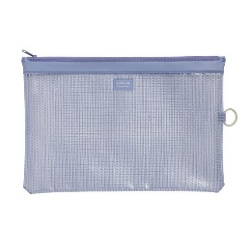The following items are to be **clearly labelled** with your child’s name.

* 1 art shirt **clearly labelled with your child’s name.**
* 1 library bag **clearly labelled with your child’s name.**
* 1 mesh document wallets A4 - **labelled with your childs name.**
* 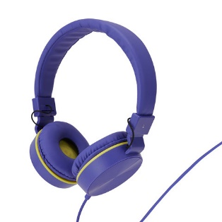1 set of headphones clearly **labelled with your child’s name.** Please make sure these have a cord and are not wireless.
* 1 set of whiteboard markers NOT labelled they are shared
* 1 pack of wind up crayons (12pk) NOT labelled
* 4 x Bostik Blu Stik glue sticks (35g) NOT labelled
* 2 x pots of Play-Doh (112g) NOT Labelled
* 1 box of tissues

Thank you for providing these things. Please, no pencil cases as pencils etc will be placed in tubs on desk to share.

Kind Regards

Josephine Gradwell and Eliza MacKinnon  
(Kindergarten Teachers)

