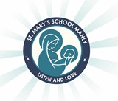
Year 1 2022 Wish List
(Kindergarten 2021)

Dear Parents,

Please supply your child with the following items for the beginning of the school year 2022.

The following items are to be shared with the class. Labelling of these items is not required.
☐ 1 x pack of wind up crayons
☐ 1 x pack of multi-coloured whiteboard markers

The following items are to be clearly labelled with your child’s name. These items can be reused from Kindergarten, they do not need to be bought new.
☐ 1 x art shirt
☐ 1 x large button calculator
☐ 1 x school library bag
☐ 3 x plastic/ mesh document wallets with zip
☐ 1 x pack of coloured textas
☐ 1 x pencil case (just large enough for the textas)
☐ 1 x set of headphones (not ear buds please)
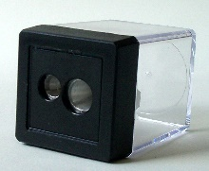
☐ 1 x medium tub of Play-Doh
☐ 1 x highlighter
☐ 1 x 2 barrel sharpener

Please Note:
- ALL items need to be labelled including school clothes, lunch boxes, drink bottles etc.

Exercise books will be sent home with your child on their MAI Assessment day to be covered with clear contact. These will need to be returned on the first official day of school.

Thank you for your continued support and we look forward to an exciting 2022! We wish you all the very best for a happy and safe Christmas

Kind regards Miss Brunskill and Mrs Conn
Year 1 Teachers

