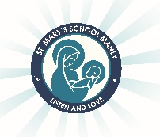
St Mary’s Catholic Primary School
2 Blue and 2 White
2022 Stationery List

Dear Parents/Carers,

As the year comes to an end, it is time to begin preparing for 2022. Listed below are the stationery and other items that your child will need to start the year. Students will be provided with the exercise books that they require for each subject area.

- 2 x plastic wallet folder
- 6 HB pencils
- Coloured textas
- Coloured pencils or crayons
- Sharpener with a shaving catcher (not electric)
- 1 x pack Whiteboard markers
- Clear 30cm ruler (not bendable)
- Medium Scissors
- 3 x large glue sticks (Bostik Blu Stik only due to WHS)
- 1 pencil case
- Art shirt/smock/oversized t-shirt
- Headphones

Please ensure that all items are labelled. This also includes school clothing, lunch boxes, drink bottles etc. Labelling reduces stress and conflict. It saves much time in returning lost property.

We wish you all a Merry Christmas, a happy and safe New Year and a wonderful holiday. We are looking forward to working with you all next year.
Kind Regards,

Alex Searl and Lisa Williams

