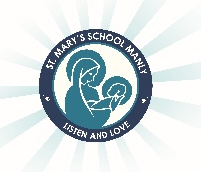
St Mary’s Catholic Primary School Year 3
2022 Stationery List

Dear Parents,

Listed below are the items your child will need for the start of Year 3. Exercise books are provided by the school.
Please purchase and label the following:

- pencil case
- 1 x plastic wallet folder
- Coloured pen (for editing)
- Coloured textas
- Coloured pencils
- Scissors
- 2 x glue sticks each term– (Bostik Blu Stik only brand due to WHS)
- Art shirt/smock
- Headphones (for use with ICT)
- A4 Sketch Pad (may have left over from last year)
- Air dry modelling clay

Homework items:
Please make these items available in your child’s homework area:
- Primary Dictionary for homework

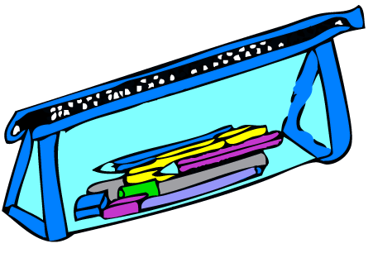

Please Note:
- ALL items need to be labelled including school clothes, lunch boxes, drink bottles etc.
We are looking forward to working with you in 2021. Enjoy your holidays!

Mrs Cathy Gualtieri, Mrs Priscilla Chang and Mrs Claire Shefford

