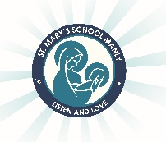
St Mary’s Catholic Primary School

- Year 5 2022 Stationery List

Dear Parents/Carers,
As the year comes to an end, it is time to begin preparing for 2022. Listed below are the stationery and other items that your child will need to start the year.

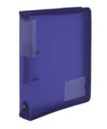
Items needed to be purchased by families:
- 1 Box of tissues
- Art Shirts or apron (they must be worn during art activities)
- Post it notes- 2 packets
- Headphones- don’t need to be expensive
- A4 2 Ring Zipper Binder
- 1 pack A4 folder dividers – approximately 8-10
- 1 pack of A4 lined paper

One pencil case large enough to include:
- 4 blue pens
- 4 black pens
- 2 red pens
- 2 2B or HB lead pencils
- Ruler
- Coloured pencils
- Sharpener and eraser
- Scissors
- Coloured textas
- Highlighters (4 colours)
- 1 Bostik Blu Stik
- 1 whiteboard marker

Please ensure that all items are clearly labelled. This also includes school clothing, hats, lunch boxes, drink bottles etc.
Have a restful and happy holiday. We’re looking forward to having a fantastic 2022.

Miss Paul Mrs Squirrell Mrs Marshall

