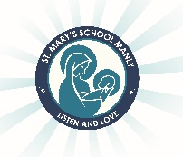
St Mary’s Catholic Primary School-

Year 6, 2022 Stationery List

Dear Parents/Carers,

As the year comes to an end, it is time to begin preparing for 2022. Listed below are the stationery and other items that your child will need to start the year. Please note that many of the required items can be re-used from Year 5, rather than purchasing everything new!

Items required:
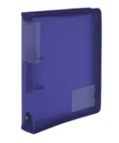
- 1 Box of tissues
- Art Shirts or apron (they must be worn during art activities)
- Post it notes- 2 packets
- Headphones- don’t need to be expensive
- A4 2 Ring Zipper Binder
- 1 pack of A4 folder dividers – approximately 8-10
- 1 pack of A4 lined paper (100 pages)

One pencil case large enough to include:
- 4 Blue pens
- 4 Black pens
- 2 Red pens
- 2 2B or HB lead pencils
- Ruler
- Coloured pencils
- Sharpener and eraser
- Scissors
- Coloured textas
- Highlighters (4 colours)
- 1 Bostik Blu Stik
- 1 Whiteboard marker
- Geometry set

Please ensure that all items are clearly labelled. This also includes school clothing, hats, lunch boxes, drink bottles etc.

Have a restful and happy holiday. I look forward to having a fantastic 2022 with your children.

Patrick Leydon

